Google UI test

Content

Base Tests 1

Address 1 – Landmark Input 1

Address 2 – Real street name 2

Address 3 – Address is an area 3

Address 4 – Address is a Country 4

Address 5 – Input can have more than one Output 4

Expansion: 5

Address 6 – Input is an empty string 5

Address 7 – Input has no capitalization 5

Address 8 – Input is a misspelled name 5

Address 9 – Input does not exists 6

Address 10 - html input 6

Address 11 - Special characters 6

Additional Requirements. 7

# Base Tests

Requirements:

Please pick at least 4 different addresses to search in google maps. Your code must be able to run on our test devices.

Considerations:

* Make it easy to build and run, do also consider maintainability
* Think of further scenarios (e.g. negative)
* Think of further requirements (e.g. cross-browser)
* Don't be afraid to surprise us!
* Documentation is always welcomed

## Address 1 – Landmark Input

|  |  |
| --- | --- |
| Text Input | Tower of Pisa |
| Expected Output | Placename == Leaning Tower of Pisa, header image, description, actionbar, address with zip code, Admissions, popular times, reviews |

**Reference Screenshot:**

Ein Bild, das Karte enthält.

## Address 2 – Real street name

|  |  |
| --- | --- |
| Text Input | Stresemannstrasse 41 |
| Expected Output | Placename == Stresemannstraße 41, header image, actionbar, address with zip code, |

**Reference Screenshot:**

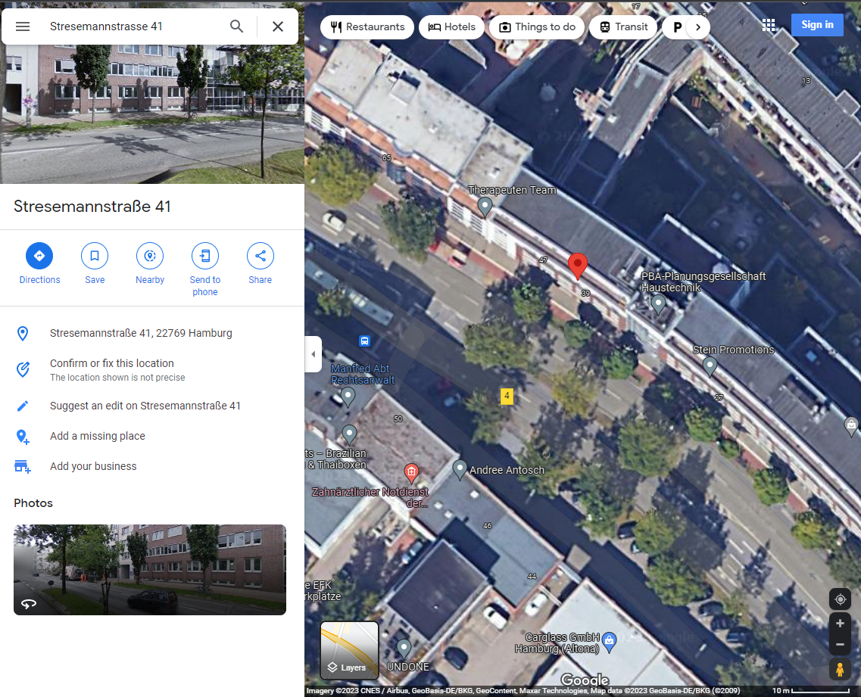

## Address 3 – Address is an area

|  |  |
| --- | --- |
| Text Input | Museumisland Berlin |
| Expected Output | placename == Museum Island, header image, action bar, description, info bar |

**Reference Screenshot:**

Ein Bild, das Karte enthält.

## Address 4 – Address is a Country

|  |  |
| --- | --- |
| Text Input | Uruguay |
| Expected Output | Placename == Uruguay, header image, quick facts, action bar |

**Reference Screenshot:**

Ein Bild, das Karte enthält.

## Address 5 – Input can have more than one Output

|  |  |
| --- | --- |
| Text Input | Washington |
| Expected Output | More than one possible result shows with the searched input. |

**Reference Screenshot:**

Ein Bild, das Karte enthält.

# Expansion:

## Address 6 – Input is an empty string

|  |  |
| --- | --- |
| Text Input |  |
| Expected Output | No changes, Current area information displays |

**Reference Screenshot:**

Ein Bild, das Karte enthält.

## Address 7 – Input has no capitalization

|  |  |
| --- | --- |
| Text Input | uruguay |
| Expected Output | same output as Uruguay test nr. 4 |

## Address 8 – Input is a misspelled name

|  |  |
| --- | --- |
| Text Input | muuseums izland |
| Expected Output | Museum Island, same as test number 3 |

## Address 9 – Input does not exists

|  |  |
| --- | --- |
| Text Input | albon ssbdds |
| Expected Output | Google Maps can’t find “misspelled name” |

**Reference Screenshot:**

Ein Bild, das Text enthält.

## Address 10 - html input

|  |  |
| --- | --- |
| Text Input | <script>  alert("Alert! Alert!");  </script> |
| Expected Output | Google Maps can't find *<script> alert("Alert! Alert!"); </script>*  Javascript is not runl. |

**Reference Screenshot:**

Ein Bild, das Text, Screenshot, Elektronik enthält.

## Address 11 - Special characters

|  |  |
| --- | --- |
| Text Input | %&5%$% |
| Expected Output | Google Maps can't find *%&5%$%, further info, no address* |

**Reference Screenshot:**

Ein Bild, das Text enthält.

# Additional Requirements.

* Allow to run in Edge as well.